**Microprocessor Interfacing Semester Project**

**Final Report**



**Haisum Riaz – 2017128**

**Samar Fatima – 2017407**

**Simaar-e-Jannat – 2017438**

**Vehicle Movement Based Street Lights**

**Vehicle Movement Based Street Lights**

**Group no:11**

**Group Members:**

Haisum Riaz ([u2017128@giki.edu.pk](mailto:u2017128@giki.edu.pk))

Samar Fatima ([u2017407@giki.edu.pk](mailto:u2017407@giki.edu.pk))

Simaar-e-Jannat ([u2017438@giki.edu.pk](mailto:u2017438@giki.edu.pk))

**Introduction**

Street lights are a raised sources of light on the edge of a road or path. Street light systems are used all over the world. They are aimed at assisting drivers during the darker part of the day. Street lights also provide light for pedestrians and keep roads visible at night. Street lights are also used for security purposes. Street lights have a wide range of applications in the real world. They are used in airports, highways and roadways, parks and playgrounds. Street lights also beautify the street and increase its commercial value. Normally, in a street light system, the photocells detect if light is needed. The flow of electricity is activated if the light is too low. Street lights are an important part of the design of a city and are carefully planned.

There are six different types of street lights that include Metal Halide street lights, High Pressure Sodium street lights, Low Pressure Sodium street lights, Light Emitting Diode street lights, Phosphor Converted Amber LED street lights and Narrow Band Amber LED street lights. Street lights are of great importance in any area. They reduce the risk of road accidents during night time. The use of street lights leads to a drop in crime rates. Street lights assist in protection of buildings and develop a feeling of security among the residents of an area.

**Project**

This project controls street lights using light dependent resistor and IR sensor. It is based on an embedded system that can be viewed as a combination of hardware and software. This project focuses on controlling street lights and involves the use of a light dependent resistor. The change in light intensity has an impact on the resistance of the light dependent resistor. When it is exposed to greater light intensity, its resistance decreases. On the other hand, when the light intensity is low, the resistance of the light dependent resistor increases. This resistance will be used to decide when the street lights are supposed to turn on. The IR sensor is used to detect vehicles on the road. The controller checks if there is no traffic and turns the lights off. The project aims to provide a good lighting system that ensures safe and smooth movement of vehicles.

**Specifications:**

The components used in this project are:

* Microcontroller: 8051 (one)
* Programming environment: C
* IR Sensors
* Light dependent resistor
* LEDS

**Circuitry and Working Principle**

The circuit of consists of 8051 microcontroller. An LDR is connected to pin 1 of the microcontroller. Seven sets of IR sensors are connected to the microcontroller from pins 33 to 39. Seven LEDs are connected to the microcontroller from pins 21 to 27. These IRs are the input devices of the circuit whereas the LEDs are the output devices of the circuit.

The purpose of this projects was to create a street light system where the lights turn on automatically when a vehicle arrives. The code for this process has been burned in the 8051 microcontroller. The IR gives a signal 1 which becomes 0 when an obstacle is detected. When a vehicle is detected by the IR sensors, the LEDs before it, with it and in front of it turn on in order to enable the driver to see both ways. Since street lights are only needed when it gets dark, LDR is used to detect light. When the light intensity is low, IR detects the obstacle and the LEDs are turned on. A delay function was added to the code and a timer was used to cause a delay of 10 milliseconds between the LEDs turning on.

Delay = 65536 – 4608

= 60928

The hardware implementation of the circuit is shown in the figure on the next page.

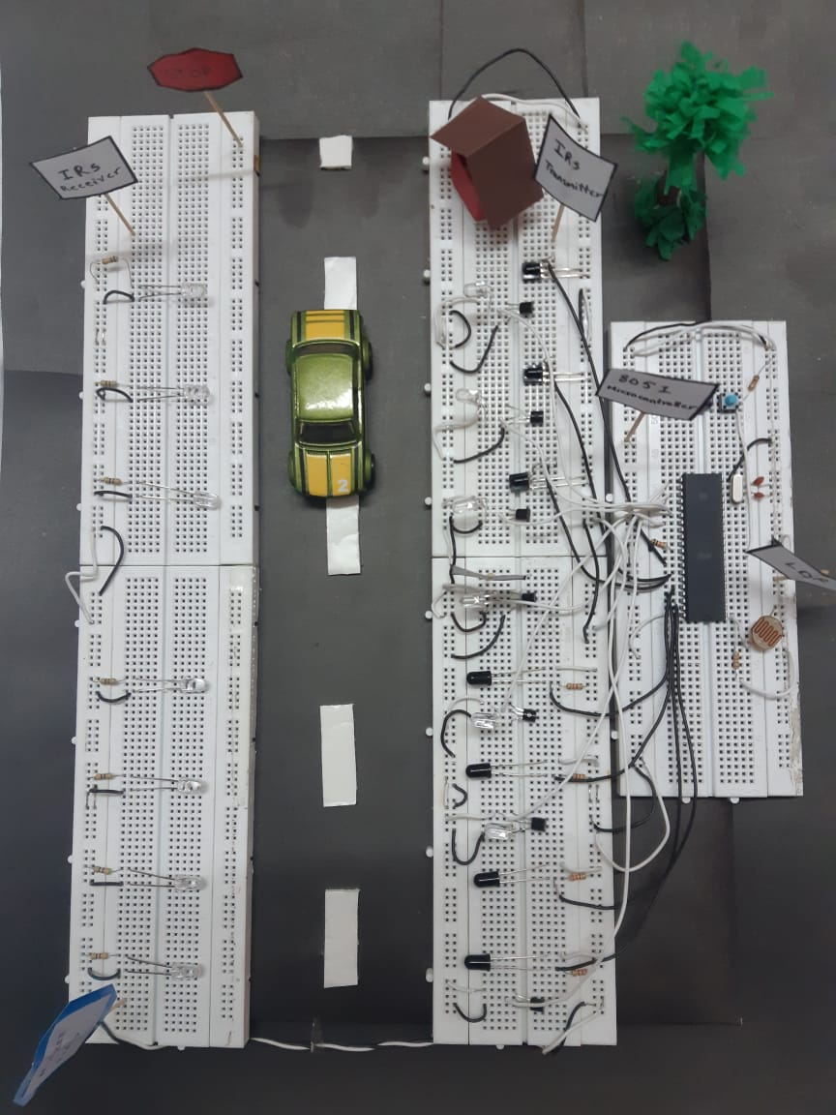

**Simulations and Discussion on Results**

The following is an image of the Proteus simulation of the project.

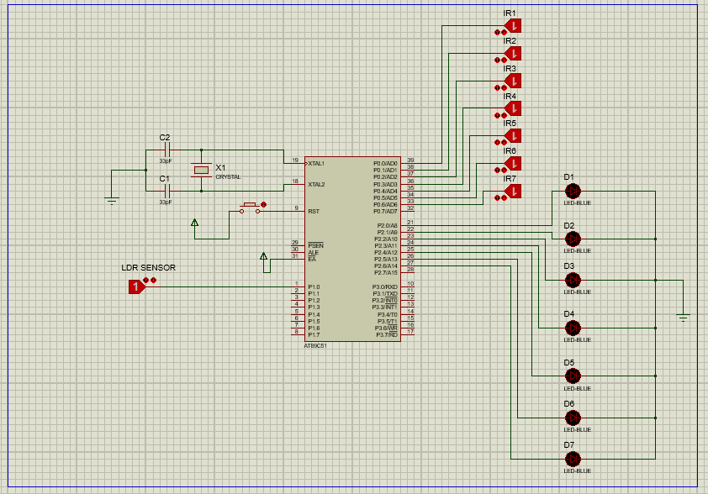

According to the Proteus results, the LEDs behind and in front of the vehicle and the LED with the vehicle turn on. However, the results implemented in hardware deviated slightly from our expectations and the LEDs behind and in front of the vehicle turn on but as the vehicle moves forward, the LEDs behind the vehicle remain on when they are supposed to turn off.

**Shortcomings and Future Work**

LEDs turn on upon detection of any obstacle and not vehicles specifically. This can be improved in future by introducing inductive loops that can be embedded on the surface of the road to detect changes in inductance and convey them to sensors in order to produce signals.

IR sensors are very delicate and do not detect signals if tilted slightly. Hence, this circuit requires regular maintenance which was a shortcoming of the project.

**References**

1. <https://science.howstuffworks.com/environmental/energy/question363.htm>

|  |  |  |
| --- | --- | --- |
| #include<reg51.h>  //ldr  void delay ( void );  sbit ir1 =P0^0;  sbit ir2 =P0^1;  sbit ir3 =P0^2;  sbit ir4 =P0^3;  sbit ir5 =P0^4;  sbit ir6 =P0^5;  sbit ir7 =P0^6;  sbit ldr =P1^0;  //leds  sbit led1= P2^0;  sbit led2 =P2^1;  sbit led3 =P2^2;  sbit led4= P2^3;  sbit led5 =P2^4;  sbit led6 =P2^5;  sbit led7= P2^6;  void main(void )  {  P1=0xFF;  led1=0;  led2=0;  led3=0;  led4=0;  led5=0;  led6=0;  led7=0;  delay(); | if( ir2==1 && ir3==1 && ir4!=1 && ir5==1 && ir6==1 && ir7==1 )  {  led3=1;led4=1;led5=1;  delay();delay();  }  if( ir2==1 && ir3==1 && ir4==1 && ir5!=1 && ir6==1 && ir7==1 )  {  led4=1;  led5=1;  led6=1;  delay();delay();  }  if( ir2==1 && ir3==1 && ir4==1 && ir5==1 && ir6!=1 && ir7==1 )  {led5=1;  led6=1;  led7=1; delay();delay();  }  if( ir2==1 && ir3==1 && ir4==1 && ir5==1 && ir6==1 && ir7!=1 )  {led6=1;  led7=1;  delay();delay();  }  if( ir1!=1 && ir2!=1 && ir3!=1 && ir4!=1 && ir5!=1 && ir6!=1 && ir7!=1 )  { | if( ir1==1 && ir2!=1 && ir3==1 && ir4==1 && ir5==1 && ir6!=1 && ir7!=1 )  {  led1=1;led2=1;led3=1;  led5=1;led6=1;led7=1;  delay();delay();  }  if( ir1!=1 && ir2==1 && ir3==1 && ir4==1 && ir5==1 && ir6!=1 && ir7!=1 )  {  led1=1;led2=1;led5=1;  led6=1;led7=1;  delay();delay();}  if( ir1==1 && ir2==1 && ir3!=1 && ir4==1 && ir5==1 && ir6!=1 && ir7==1 )  {led2=1;led3=1;led4=1;  led5=1;led6=1;led7=1;  delay();delay();  }  if( ir1==1 && ir2==1 && ir3!=1 && ir4==1 && ir5!=1 && ir6!=1 && ir7==1 )  {led2=1;led3=1;led4=1;  led5=1;led6=1;led7=1;  delay();delay();  }  if( ir1!=1 && ir2!=1 && ir3!=1 && ir4!=1 && ir5!=1 && ir6!=1 && ir7==1 ){  led1=1;led2=1;led3=1;  led4=1;led5=1;led6=1;led7=1;delay();delay();  }  if( ir1==1 && ir2==1 && ir3==1 && ir4==1 && ir5==1 && ir6==1 && ir7==1 ) |

**Code**

|  |  |  |
| --- | --- | --- |
| while(1)  {  if(ldr==1)  {  P0=0xFF; //set as input port  led1=1;  delay();delay();  while(1)  {  if( ir1!=1 && ir2!=1 && ir3==1 && ir4==1 && ir5==1 && ir6==1 && ir7==1 )  {  led1=1;led2=1;led3=1;  delay();delay();  }  if( ir1!=1 && ir2==1 && ir3==1 && ir4==1 && ir5==1 && ir6==1 && ir7==1 )  {  led1=1;led2=1;  delay();delay();  }  if( ir2!=1 && ir3==1 && ir4==1 && ir5==1 && ir6==1 && ir7==1 )  {  led1=1;led2=1;led3=1;  delay();delay();  }  if( ir2!=1 && ir3!=1 && ir4==1 && ir5==1 && ir6==1 && ir7==1 )  {  led1=1;led2=1;led3=1;led4=1;  delay();delay();  }  if( ir2==1 && ir3!=1 && ir4==1 && ir5==1 && ir6==1 && ir7==1 )  {  led2=1;led3=1;led4=1;  delay();delay();  }  if( ir2==1 && ir3==1 && ir4!=1 && ir5==1 && ir6==1 && ir7==1 )  led4=1;  delay();delay();  } | led1=1;led2=1;led3=1;  led4=1;led5=1;led6=1;led7=1;  delay();delay();  }  if( ir2!=1 && ir3==1 && ir4==1 && ir5!=1 && ir6==1 && ir7==1 )  {  led1=1led2=1;led3=1;  led4=1;led5=1;led6=1;delay();delay();  }  if( ir2!=1 && ir3==1 && ir4==1 && ir5==1 && ir6!=1 && ir7==1 )  {led1=1;led2=1;led3=1;  led5=1;led6=1;led7=1 delay();delay();  }  if(ir1==1 && ir2==1 && ir3==1 && ir4==1 && ir5==1 && ir6!=1 && ir7!=1 ){led5=1;led6=1;led7=1;  delay();delay();}  if(ir1==1 && ir2==1 && ir3==1 && ir4==1 && ir5!=1 && ir6==1 && ir7!=1 ){  led4=1;led5=1;led6=1;led7=1; delay();delay();  }  if(ir1==1 && ir2==1 && ir3!=1 && ir4==1 && ir5==1 && ir6==1 && ir7!=1 ){led2=1;  led3=1;  led4=1;  led6=1;  led7=1; delay();delay();  }  if( ir1==1 && ir2==1 && ir3!=1 && ir4==1 && ir5!=1 && ir6==1 && ir7!=1 ){  led2=1;led3=1;led4=1;  led5=1;led6=1;led7=1;  delay();delay();}  if( ir1==1 && ir2==1 && ir3==1 && ir4==1 && ir5!=1 && ir6!=1 && ir7!=1 )  {led4=1;led5=1;led6=1;led7=1;  delay();delay();}  if( ir1==1 && ir2==1 && ir3==1 && ir4!=1 && ir5==1 && ir6!=1 && ir7!=1 ){  led3=1;led4=1;led5=1;  led6=1;led7=1;  delay();delay();  }if( ir1==1 && ir2==1 && ir3!=1 && ir4==1 && ir5==1 && ir6!=1 && ir7!=1 ){  led2=1;led3=1;led4=1;led5=1;  led6=1;led7=1; delay();delay();  } | {  led1=1;  delay();delay();  }  delay();delay();  }}  }}  void delay(void )//5ms delay  { TMOD=0x01;  TH0=0x0EE;  TL0=0x00;  TR0=1;//start  while(TF0==0)  {}  TR0=0;//stop  TF0=0;    } |